**Results for Self-consistency test**

Table 1 shows the several deep classifiers were utilized to assess self-consistency test. All the classifiers have obtained accuracies near 100% across all evaluation measures, indicating consistent alignment of all predictors with the data.

Table Self consistency Results

|  |  |  |  |  |
| --- | --- | --- | --- | --- |
| **Classifier** | **Accuracy** | **Sensitivity** | **Specificity** | **MCC** |
| FCN | 0.985 | 0.988 | 0.981 | 0.969 |
| CNN | 0.998 | 1 | 0.995 | 0.995 |
| LSTM | 0.998 | 1 | 0.995 | 0.995 |
| GRU | 0.997 | 0.997 | 0.997 | 0.995 |
| RNN | 0.987 | 0.978 | 0.995 | 0.974 |
| Bi-LSTM | 0.998 | 0.998 | 0.998 | 0.997 |

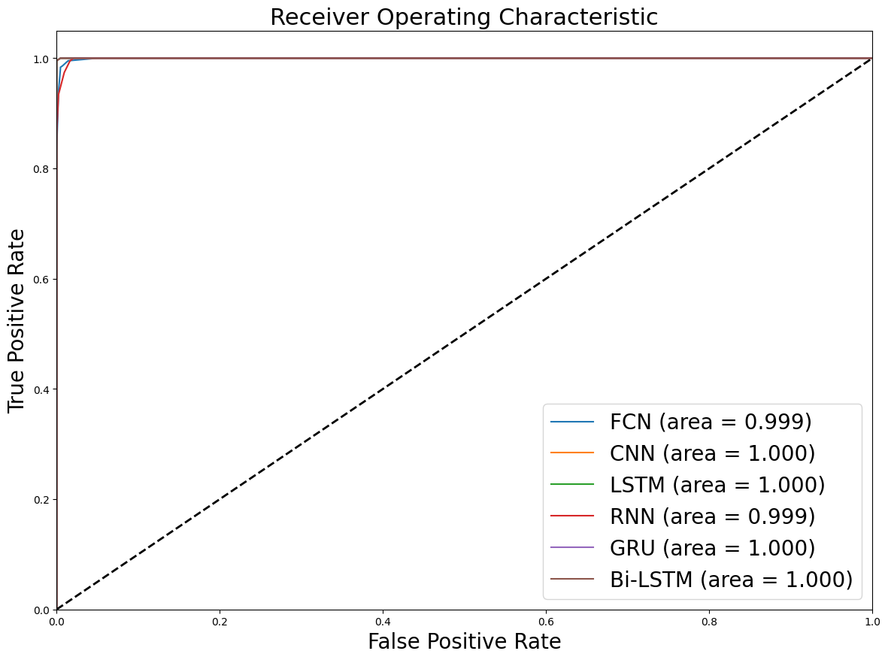

Figure Roc Curve for Self-consistency test

The ROC score of each classifier has been shown in figure 1 for self-consistency test. All classifiers attained score near 100%. Figure 1 depicts this visually, demonstrating that all employed classifiers achieved the maximum AUC score.